ROCK CYCLE

Rocks in all three families - igneous, sedimentary and metamorphic - are constantly being eroded or weathered into sediments or changed by magma.

This relationship is best described in the rock cycle.

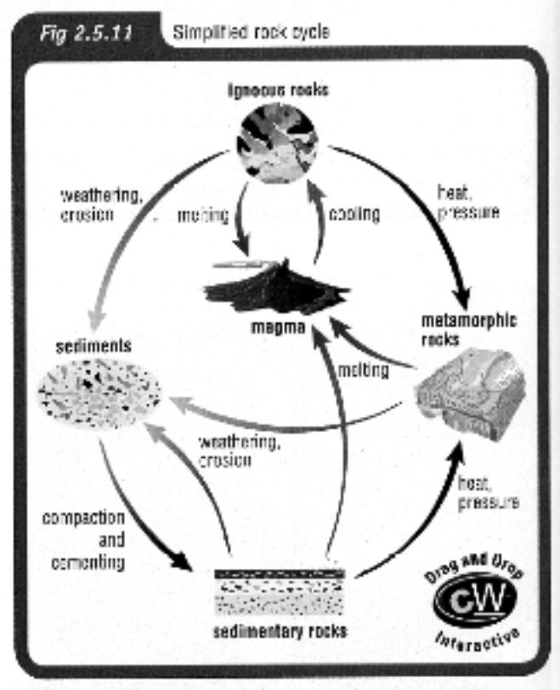

AGE OF ROCKS

It is difficult to know the exact age of rocks.

One way is to measure the amount of radioactivity due to known amounts of radioactive substances.

e.g. uranium.

An easier method is to determine the relative ages of rocks.

e.g. In forming sedimentary rocks, the oldest sediments are at the bottom
and the younger ones are on top.

This is the Principle of Superposition - younger features occur on top of older features.

